Quick Reference to OpenSCAD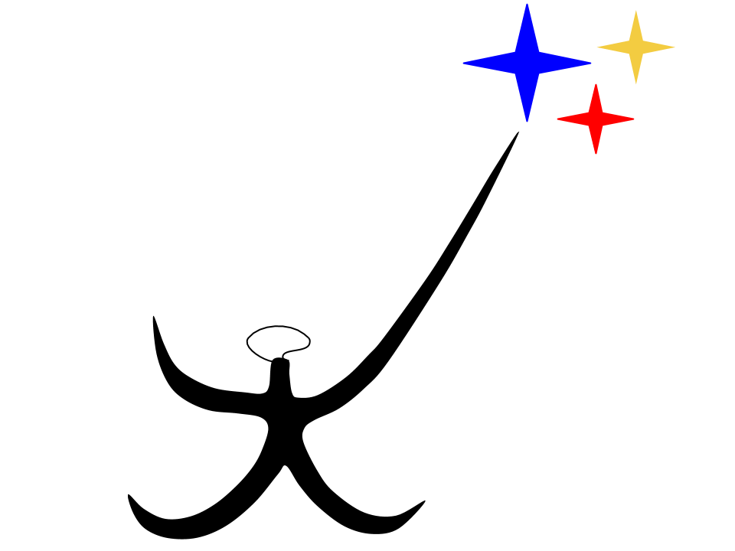

Dov Kruger

# References

## Information on OpenSCAD

To download: <http://www.openscad.org/downloads.html>

Cheatsheet with more details: <http://www.openscad.org/cheatsheet/>

Full Reference Manual: <http://www.openscad.org/documentation.html>

## Places to Get Open Source Designs

Open Source parts in OpenSCAD and STL: <http://www.thingiverse.com>

## Free CAD Tools (Instead of Programming)

Autodesk 123D: <http://www.123dapp.com/>

TinkerCAD: <https://www.tinkercad.com/>

Google Sketchup: <http://www.sketchup.com/>

Blender (movie editor but can also save to .stl files): <https://www.blender.org/>

## Videos on 3D Printing

Information about 3D printing: <https://www.youtube.com/watch?v=0-DNo8JKOMU>

Building a 3D delta printer: <https://www.youtube.com/watch?v=ua2QKV8V234>

Using a CNC router to create a face in wood: <https://www.youtube.com/watch?v=CcOQpAj_Ovc>

Building a CNC Router: <https://www.youtube.com/watch?v=yLfHb9LRWuc>

Building houses with 3d printers (China): <https://www.youtube.com/watch?v=SObzNdyRTBs>

3d printing a backyard castle (US): <https://www.youtube.com/watch?v=DQ5Elbvvr1M>

WASP: Houses for Africa: <https://www.youtube.com/watch?v=CZMTQLVTJdA>

## 

## Different Kinds of Printers

This is for information only, I have not tested these so I am not endorsing them!

CNC Router (kit and assembled): <http://www.mydiycnc.com/>

Information on automated manufacturing: <http://www.cnc4everyone.com/>

Best current 3d printer for $299: <https://www.monoprice.com/product?p_id=13860>

Not a kit!!!

I like the Prusa I3 design and own one. There are many clones.

This is the company I bought from, not great but REALLY CHEAP: <https://www.amazon.com/ALUNAR-Desktop-Printer-Accuracy-Assembly/dp/B018XJ3E02/ref=sr_1_1?ie=UTF8&qid=1500241285&sr=8-1-spons&keywords=prusa+i3&psc=1>

currently $215!!!

# 

# 

# 2D Commands

square(20);

square([20,10]);

circle(10);

polygon( points=[ [0,0], [100,0], [0,100]], paths=[[0,1,2]] );

text(“Dov Kruger”);

text(“Dov Kruger”, 32, “Times”);

Things with 360 degree symmetry (like circles) have centers on the origin.

Things with corners have the corner on the origin. To center a square:  
square(20, center=true);

# 3D Primitives

cube(30);

cube(30, center=true);

cube([30,20,10]); // a slab (poorly named, not all dimensions equal)

sphere(19);

cylinder(r=10, h=50);

cylinder(r=20, h=30, center=true);

cylinder(r1=5, r2 = 10, h=30, center=true); // a truncated cone with smaller radius 5

cylinder(r2=10, h=30, center=true); // a cone

# 

# 

# Transformations

translate([30,0,0])

cube(10); // move this cube 30 in the x

translate([30,0,0]) {

cube(10); // move both shapes in the curly braces by 30 in the x

sphere(5);

}

rotate(90, [1,0,0]) { //rotate around x axis

cylinder(r=5, h=30);

}

rotate(90, [0,1,0]) {//rotate around y axis

cylinder(r=5, h=30);

}

rotate(90, [0,0,1]) { //rotate around z axis

cylinder(r=5, h=30);

}

scale([2,.5,.5])

sphere(10);

# 

# 

# Extrusion

Imagine creating a hole with a certain shape, then pushing something soft through the hole. This process is called extrusion and it is a great way to turn 2d shapes into 3d shapes.

| linear_extrude(height=50) square(10); | Create a rectangular prism by extruding a square |  |
| --- | --- | --- |
| linear_extrude(height=50, twist=720)  square(10); | Create a spiral staircase by twisting while extruding |  |
| linear_extrude(height=50, twist=720)  square(10, center=true); | Create a threaded machine screw |  |
| linear_extrude(height=50, twist=720, scale=0.1)  square(10, center=true); | Twist and shrink as extrusion progresses |  |
| rotate_extrude()  translate([20,0])  square(10); | Extrude along a circular path |  |

# 

# Difference, Union and Intersection

| difference() { cube(30, center=true);  cylinder(r=10, h=30, center=true);  } | cube with a hole drilled through it |  |
| --- | --- | --- |
| difference() {  cylinder(r=10, h=30, center=true);  cylinder(r=9, h=30, center=true);  } | hollow pipe |  |
| union() {  cylinder(r=10, h=30, center=true);  rotate(90, [0,1,0])  cylinder(r=10, h=30, center=true);  } | two cylinders at right angles |  |
| intersection() {  cylinder(r=10,h=30);  translate([5, 0,0])  sphere(10);  } | intersection of a cylinder and a sphere that is offset |  |

# 

# 

# Functions (called modules in OpenSCAD)

Modules define sequences of operations that can be called, making programs shorter and modular. Once you define a module, you can repeatedly call it.

module pipe(OD, ID, L) {

difference() {

cylinder(r=OD/2, h=L);

cylinder(r=ID/2, h=L+.1);

}

}

pipe(20, 18, 40);

# Loops

Using variables OpenSCAD can compute repetitively (a loop). The for loop looks like this:

for (var = [start:step:end])

| for (x = [0:10:50])  translate([x,0,0])  cube(5); | create 6 cubes at x = 0, x = 10, x=20, … up to x = 50 |  |
| --- | --- | --- |
| for (x = [0:10:50])  for (y = [0:10:50])  translate([x,y,0])  cube(5); | create a 6x6 grid of cubes |  |
| for (a = [0:45:360])  rotate(a, [0,1,0])  cylinder(r=5, h=20); | 8 cylinders radiating out from the origin |  |

# Miscellaneous

minkowski() { // makes a cube with rounded edges

cube(30, center=true);

sphere(10);

}

hull() {

sphere(10);

translate([10, 0])

sphere(10);

translate([0, 10])

sphere(10);

}

# 

# 

# Challenge Problems

1. Create a flat plate 30x20x1.
2. Create a rectangular table with four legs that are rectangular prisms
3. Create a table with four cylindrical legs.
4. Create a table with four legs that are pipes with an outside diameter of 2, an inside diameter of 1.8, a height of 20, a length of 50 and a width of 25.
5. Create something that looks like R2D2 from Star Wars.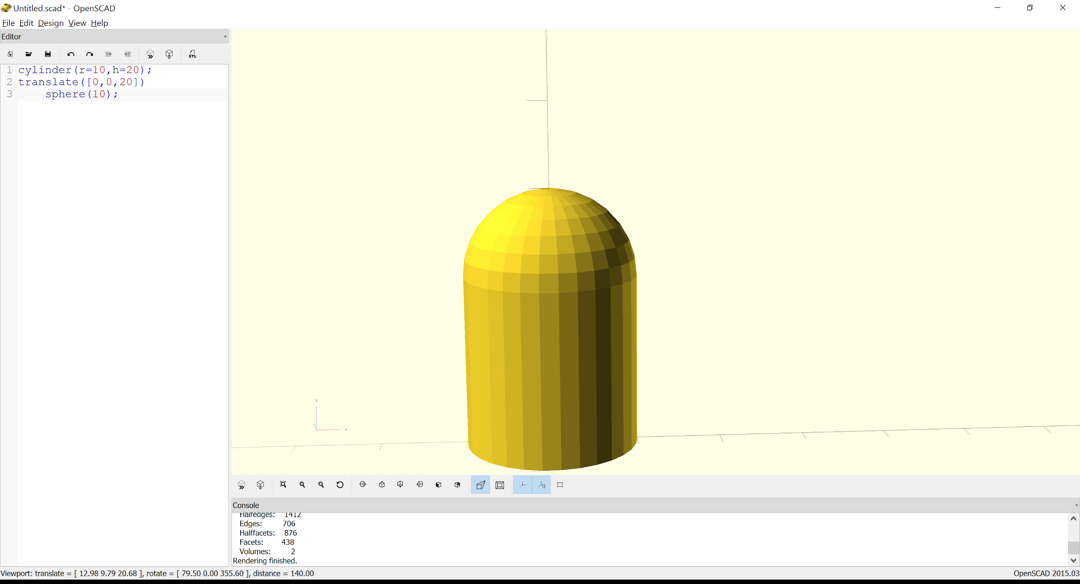
6. Create faceplates like the following:

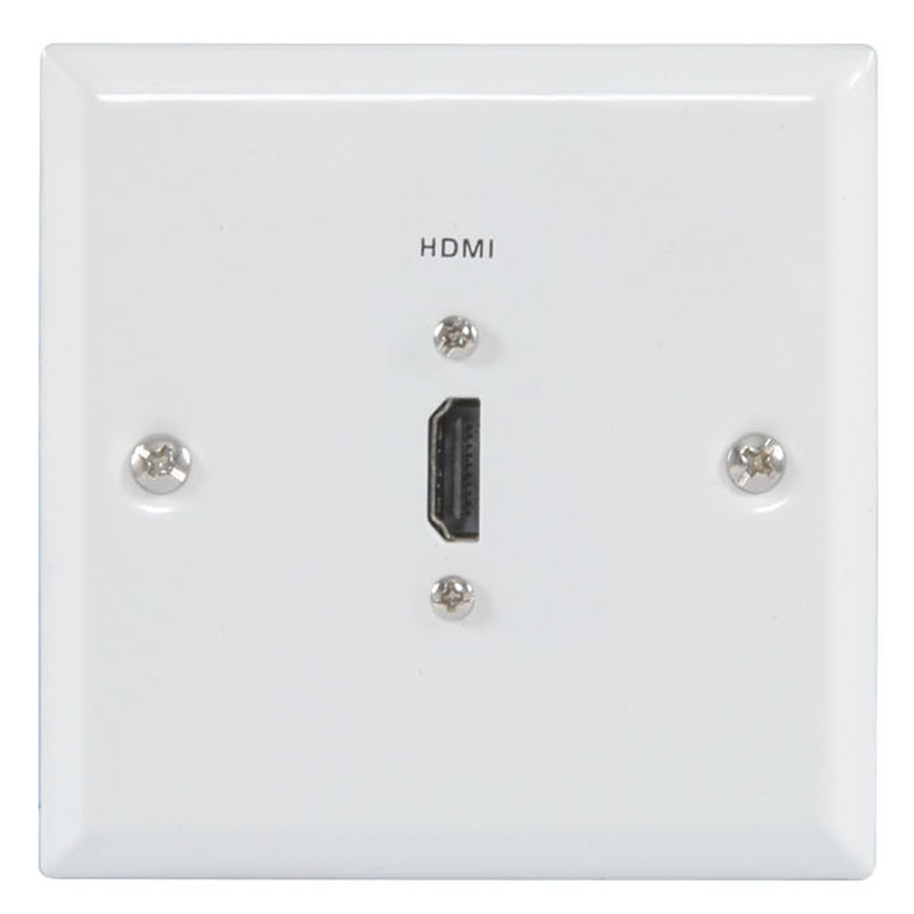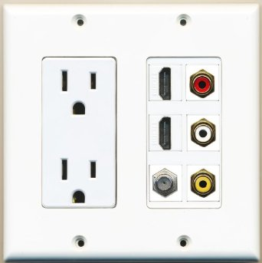

1. Create a Ziggurat (Babylonian step pyramid). 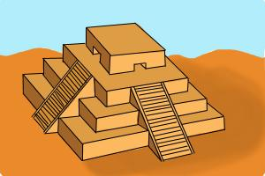
2. Create a central hub with 8 cylindrical spokes. 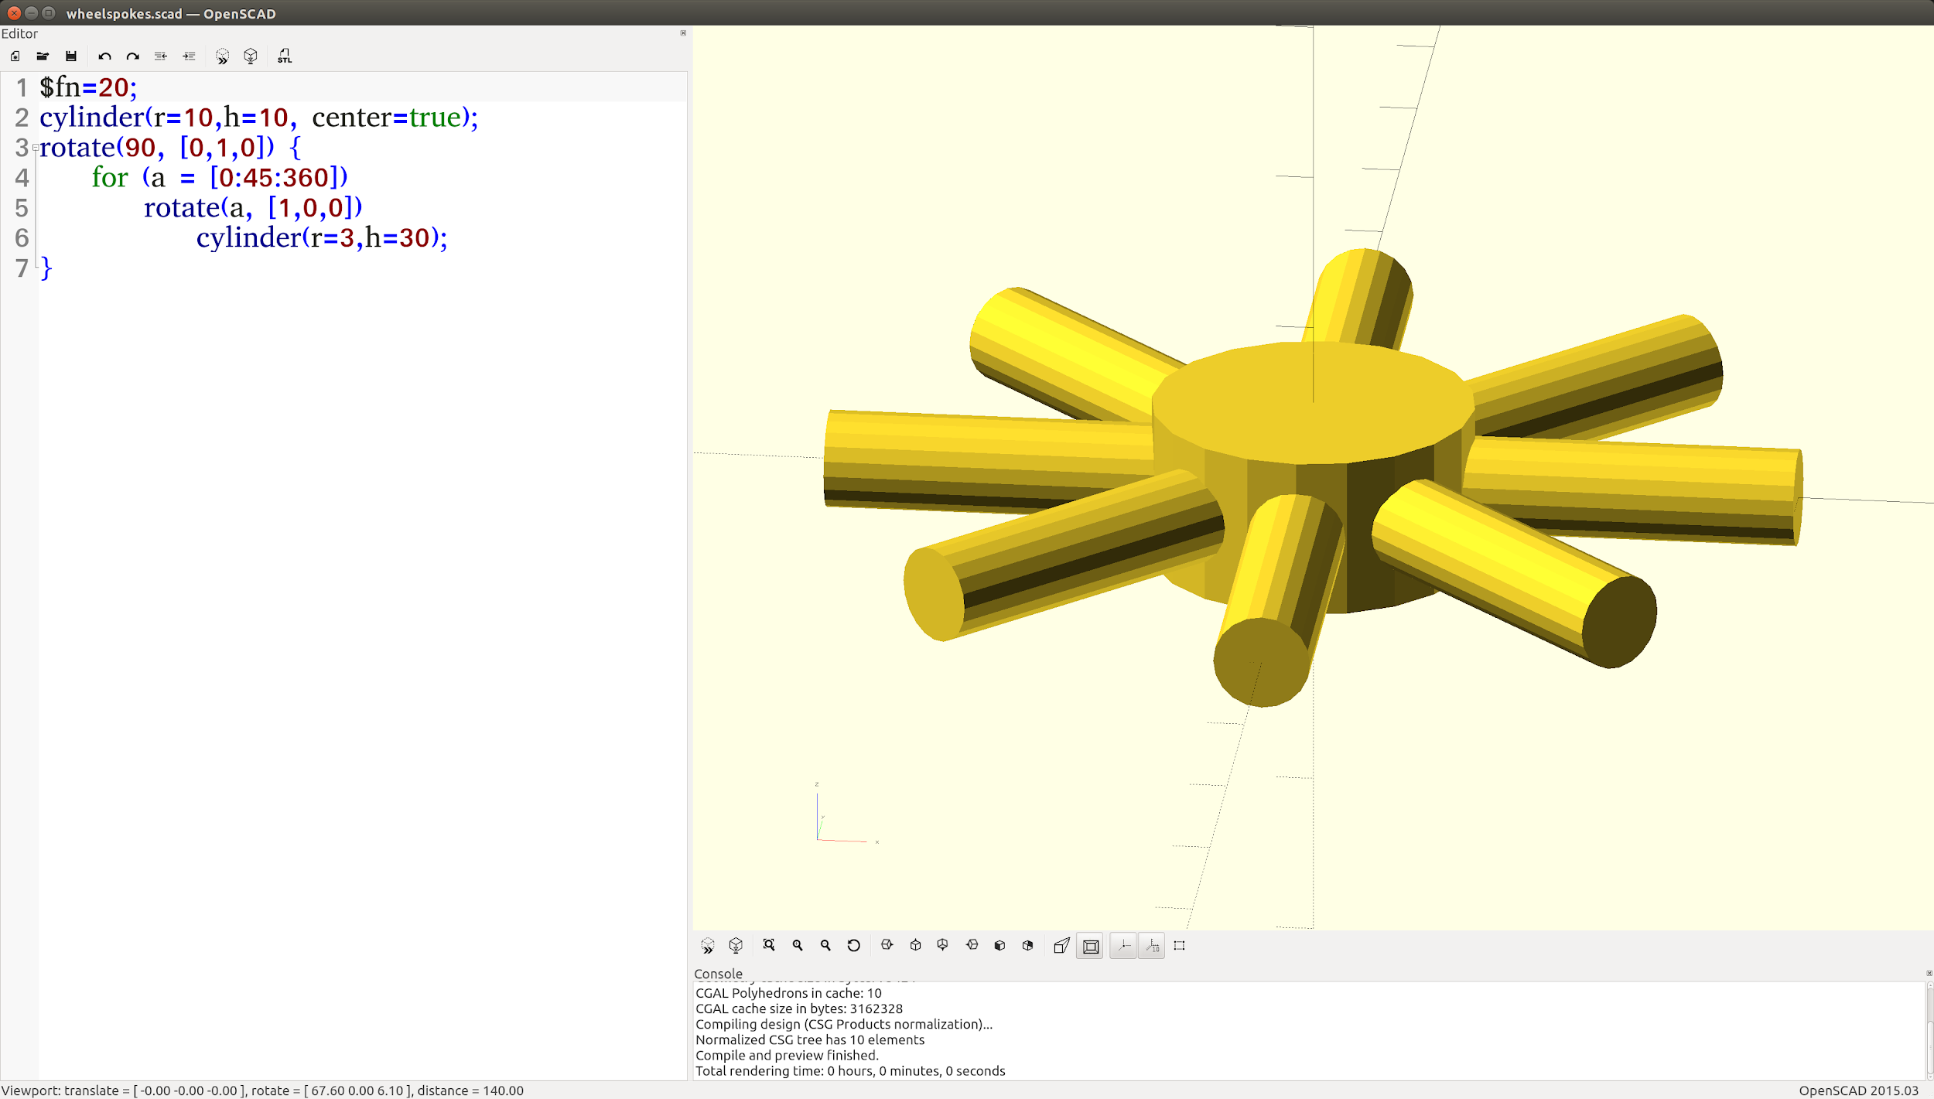
3. Add a rim to the above wheel.
4. Create something fun and interesting!
5. Create your name in 3d.
6. Create a nameplate with your name carved into it.
7. Create the nose of a torpedo.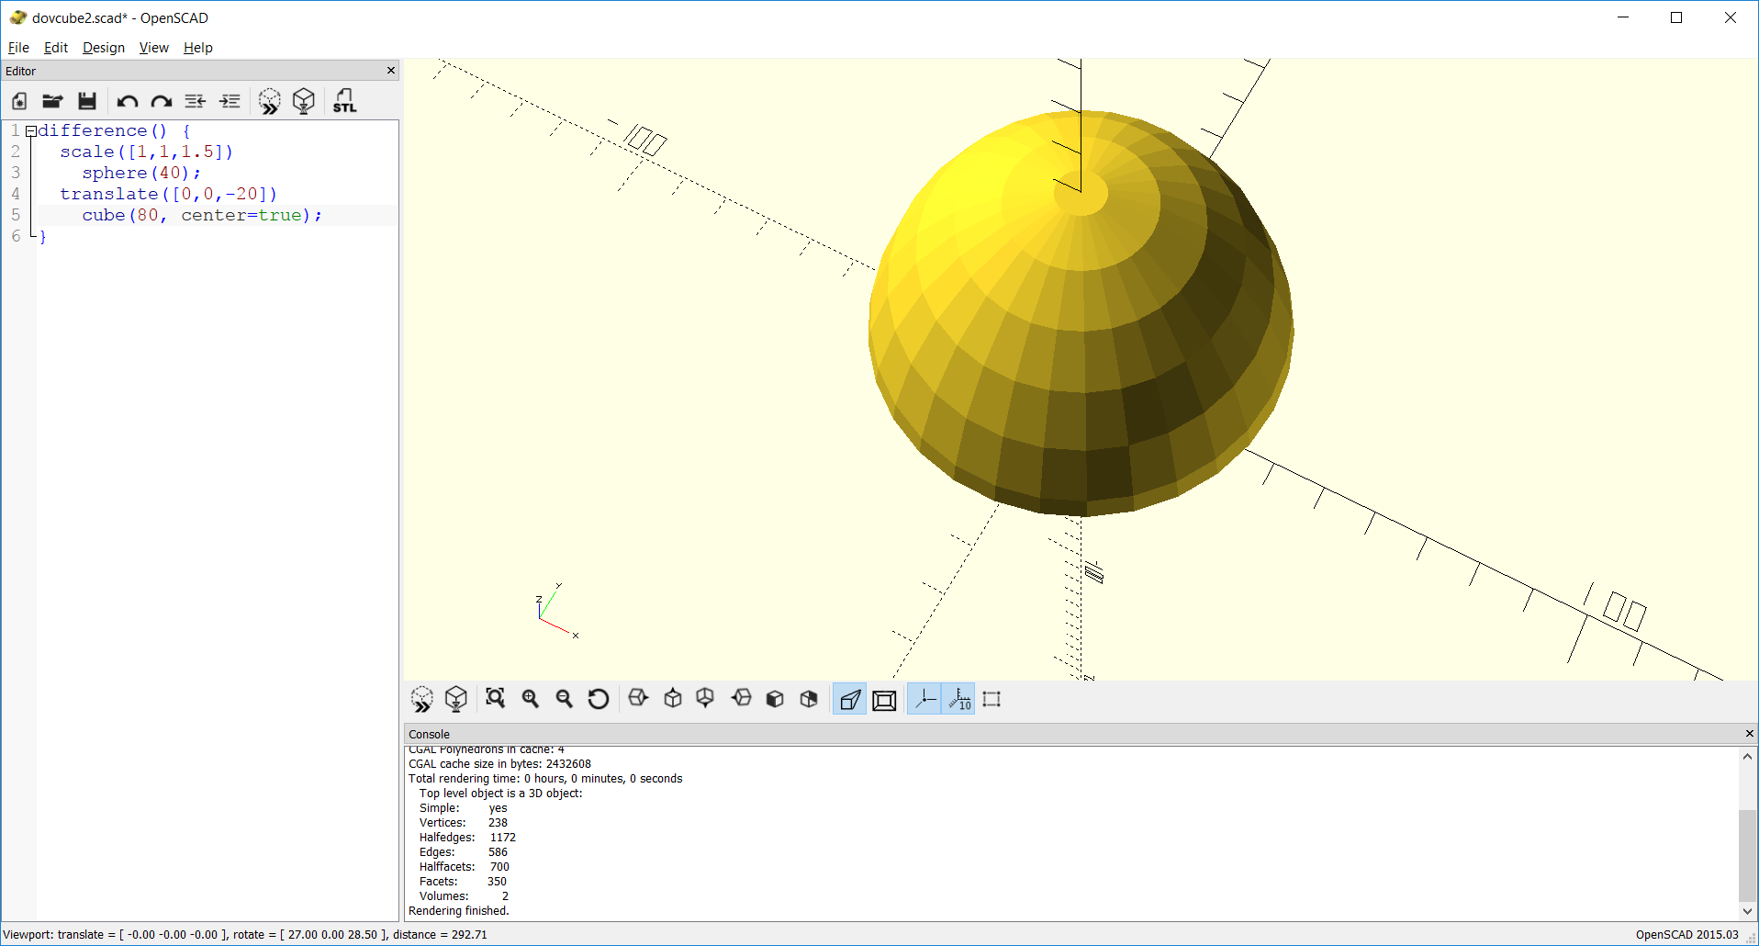
8. Create a cube with a sphere carved out of it like this: 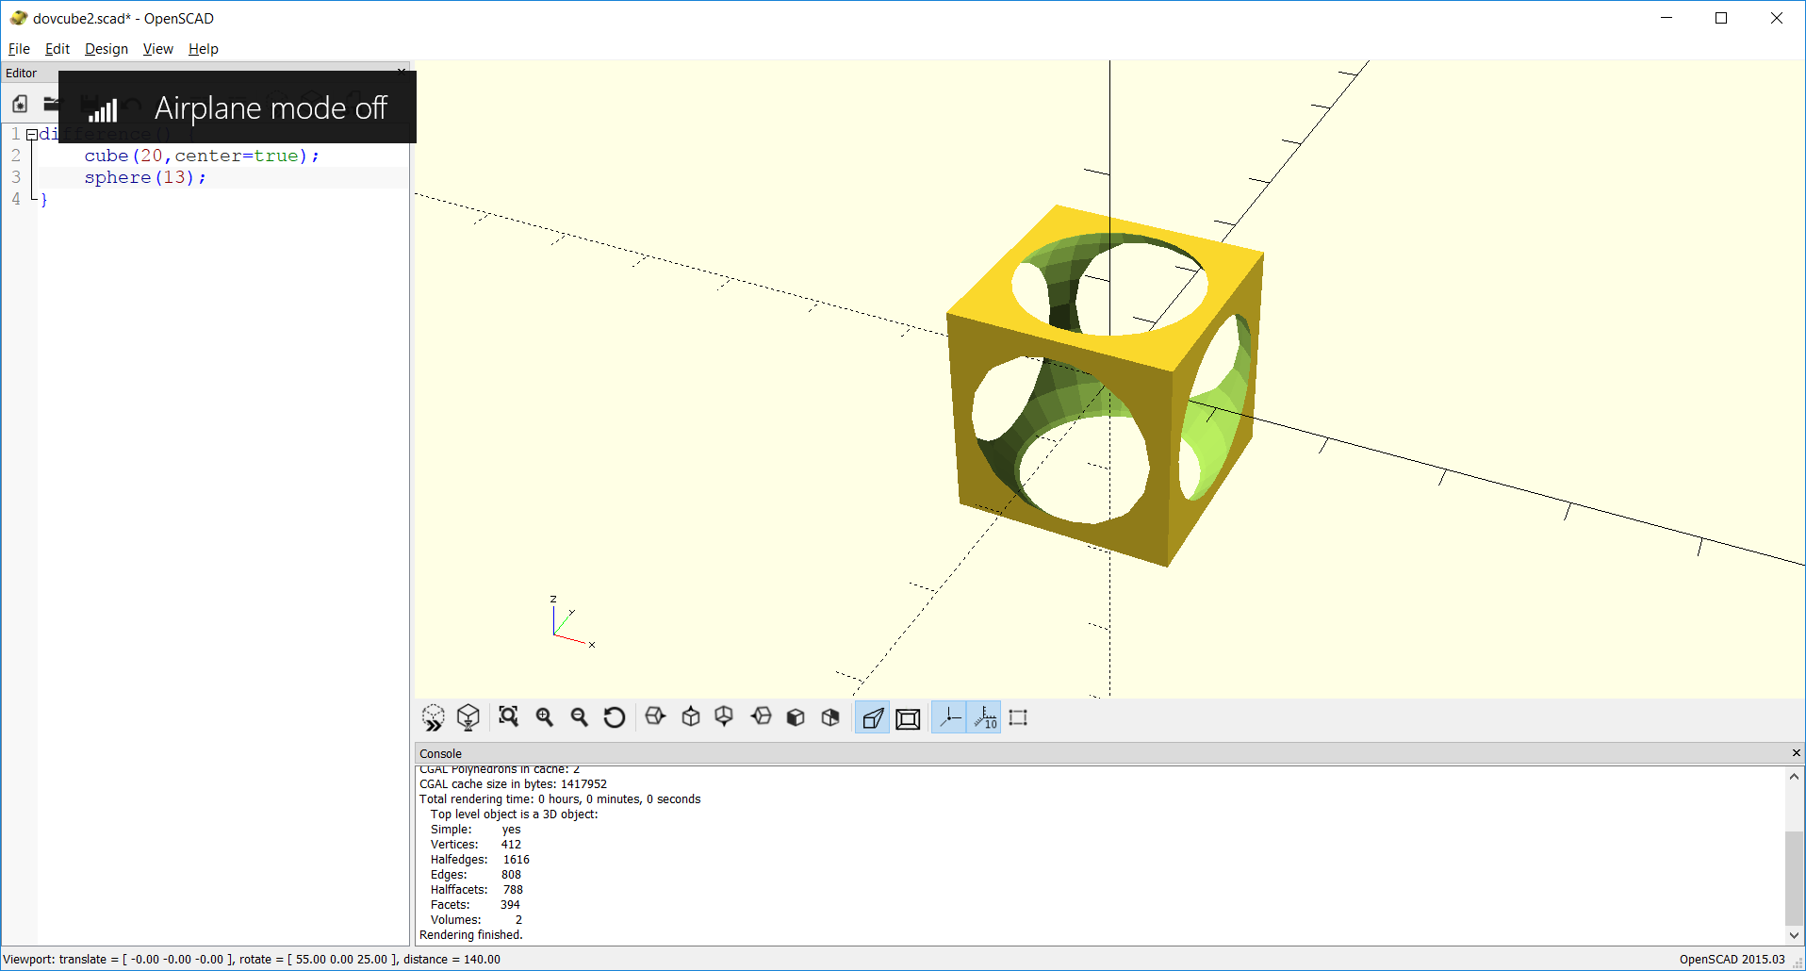
9. Full bicycle wheel with rim (simplified, not this actual picture!).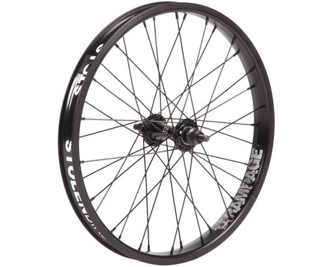
10. A submarine.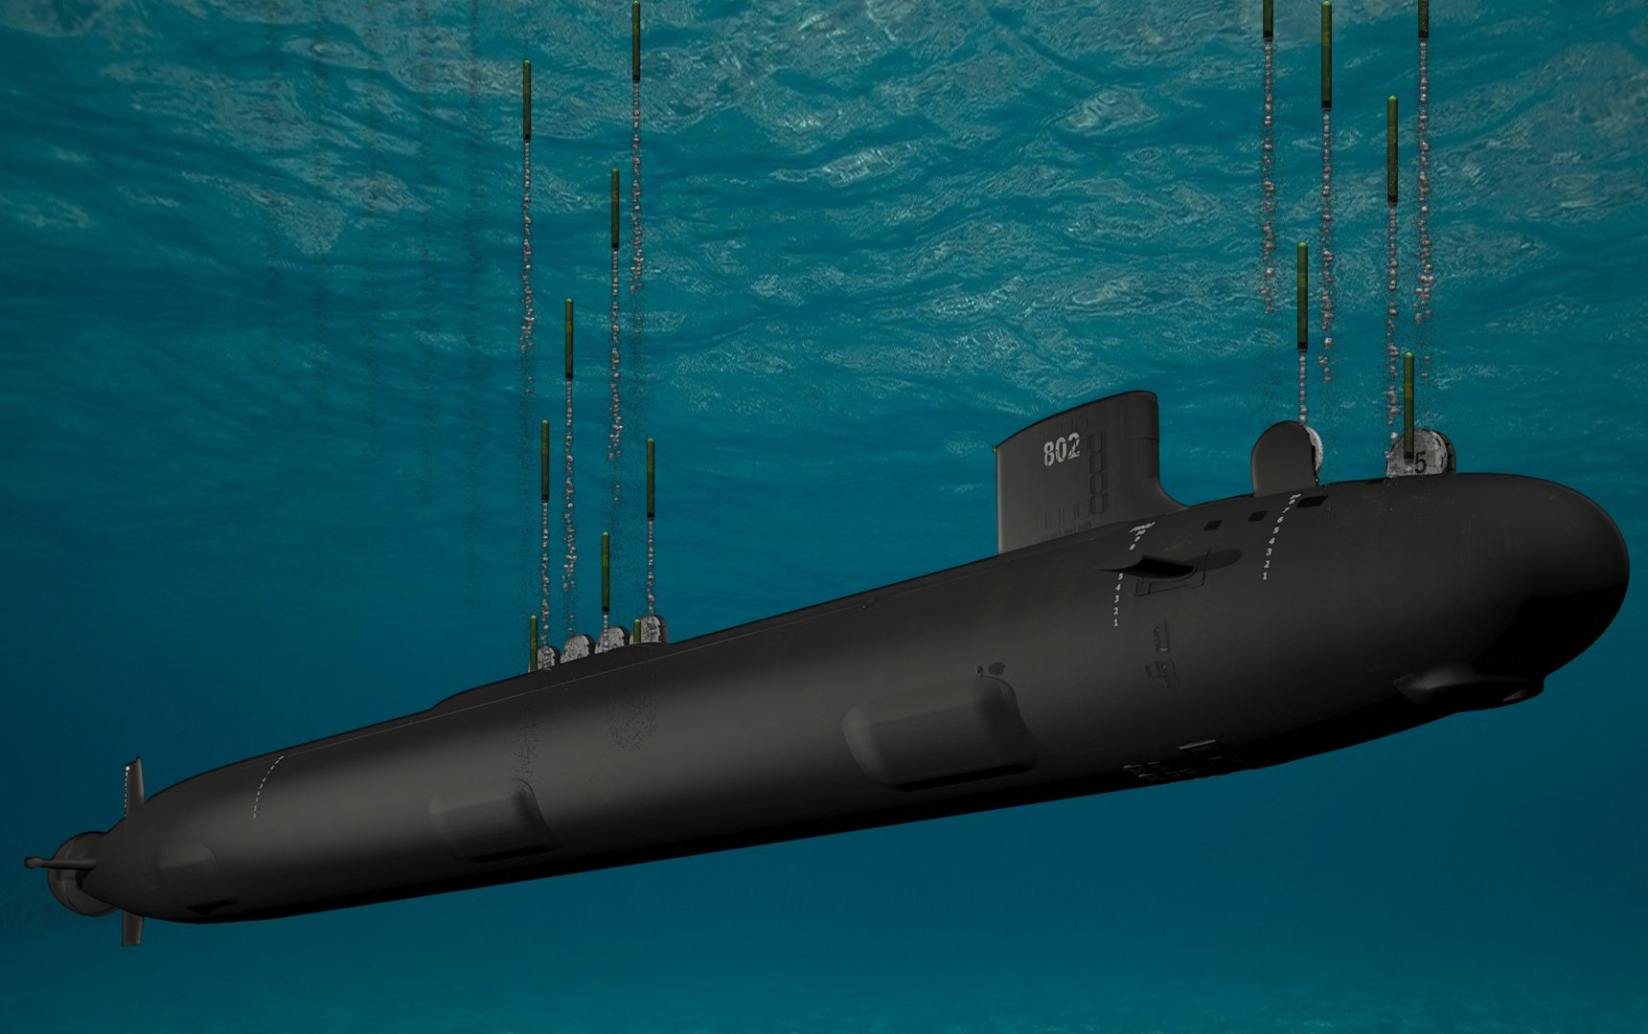
11. torpedo